**Coding Assignment 2**

***Shubham Maheshwari(17EC10055)***

When humans view a color object, we describe it by its hue, saturation, and Brightness. Hue is a color attribute that describes a pure color (pure yellow, orange, or red), whereas saturation gives a measure of the degree to which a pure color is diluted by white light. Brightness embodies the achromatic notion of intensity and is one of the key factors in describing color sensation. Intensity (gray level) is a most useful descriptor of monochromatic images. This quantity definitely is measurable and easily interpretable. The HSI (hue, saturation, intensity) color model, decouples the intensity component from the color-carrying information (hue and saturation) in a color image.

Given an image in RGB color format, the H component of each RGB pixel is obtained using the equation:

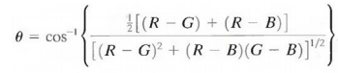

The saturation component is given by:



Finally, the intensity component is given by:



**TASK-1 Observations and Discussion**

* Each of the RGB components for every image was multiplied by ‘p’, which I took to be 0.75.
* Since p belonged between (0,1), the intensity was reduced for all the 10 images, since the RGB values were reduced to a fraction of their original values, hence the negative value for the differences calculated.
* Since multiplying the rgb values by a rational number doesn’t affect the value of theta(θ), consequently doesn’t affect the Hue value. Similarly saturation also isn’t affected by the multiplication of a factor. Hence the differences of H and S calculated for all the images were 0.

***TASK 1 table for the average hue, saturation and intensity differences for p = 0.75***

**Image H_diff S_diff I_diff**

**1.tiff 0.0000 0.0000 -0.0333**

**2.tiff 0.0000 0.0000 -0.1156**

**3.tiff 0.0000 0.0000 -0.1378**

**4.tiff 0.0000 0.0000 -0.1641**

**5.tiff 0.0000 0.0000 -0.1068**

**6.tiff 0.0000 0.0000 -0.1240**

**7.tiff 0.0000 0.0000 -0.1783**

**8.tiff 0.0000 0.0000 -0.1210**

**9.tiff 0.0000 0.0000 -0.1085**

**10.tiff 0.0000 0.0000 -0.1257**

**TASK-2 Observations and Discussion**

* The [R,G,B] components of each image were essentially modified into [G,B,R] by the transformation given.
* Since the R,G,B values were just swapped with each other, hence it didn’t affect the Intensity that depends on the sum of these values.
* Similarly, it didn’t affect the value of Saturation, hence the differences of I and S calculated for all the images were 0.
* This kind of transformation only affected the value of Hue for all images and depending on the values the hue(angle) increased or decreased for the 10 images.

***TASK 2 table for the average hue, saturation and intensity differences in the 10 color images given***

**Image H_diff S_diff I_diff**

**1.tiff 84.5641 0.0000 0.0000**

**2.tiff -121.6403 0.0000 0.0000**

**3.tiff -1.2233 0.0000 0.0000**

**4.tiff 223.1328 0.0000 0.0000**

**5.tiff -6.3182 0.0000 0.0000**

**6.tiff 81.1576 0.0000 0.0000**

**7.tiff -92.5622 0.0000 0.0000**

**8.tiff 45.8623 0.0000 0.0000**

**9.tiff 201.1653 0.0000 0.0000**

**10.tiff 75.7435 0.0000 0.0000**

**TASK-3 Observations and Discussion**

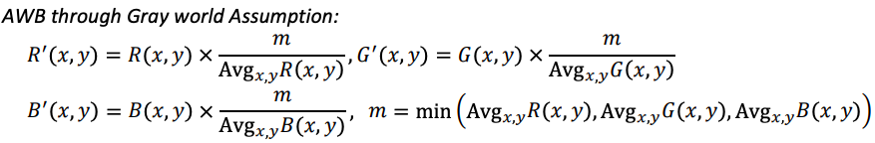

* Automatic white balance (AWB) algorithms try to correct for the ambient light with minimum input from the user, so that the resulting image looks like what our eyes would see.
* All the RGB values were multiplied by the fraction minimum of all averages among (R,G,B) upon the respective averages, hence a guaranteed reduction in the Intensity.

***TASK 3 table for the average hue, saturation and intensity differences in the 10 color images given***

**Image H_diff S_diff I_diff**

**1.tiff 42.4514 -0.0279 -0.0253**

**2.tiff -75.8391 0.0014 -0.0730**

**3.tiff -15.4723 0.0053 -0.0295**

**4.tiff 114.9365 -0.0682 -0.0982**

**5.tiff -66.6907 -0.1502 -0.1506**

**6.tiff 37.2532 -0.0070 -0.0523**

**7.tiff -54.4535 0.0092 -0.0167**

**8.tiff 50.7070 0.0043 -0.0334**

**9.tiff 106.4518 -0.1056 -0.1730**

**10.tiff -14.5038 -0.1297 -0.1144**